Practical 5

**Study and implementation of identity management.**

**Creating an instance:**

1. Login to openstack dashboard.

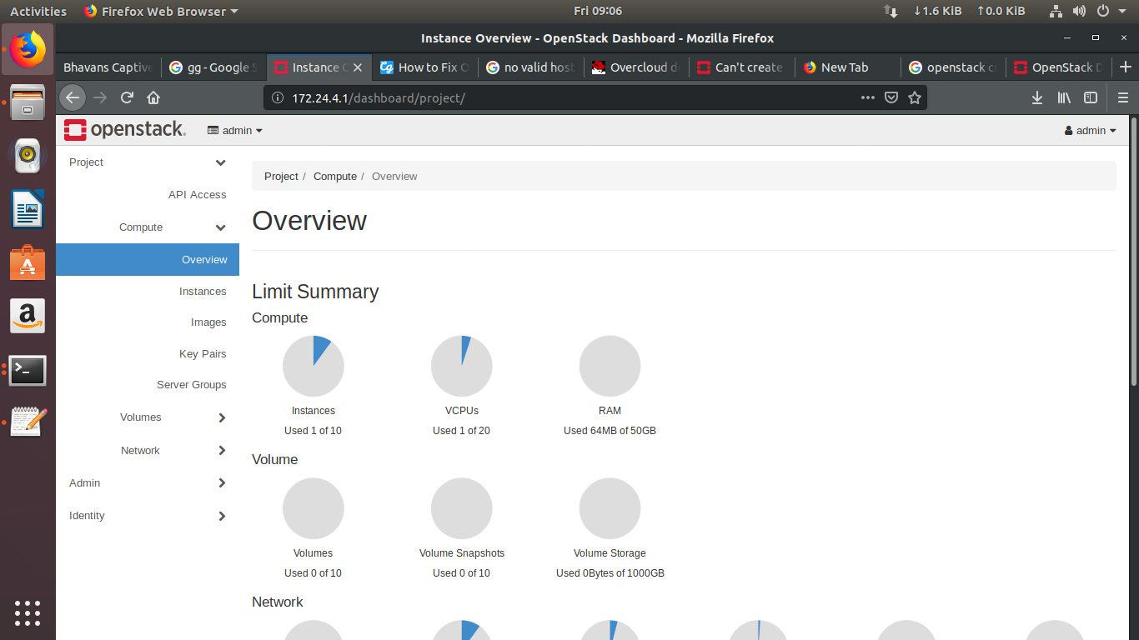

1. Go to compute>> Instances and click launch instance and fill details of instance.

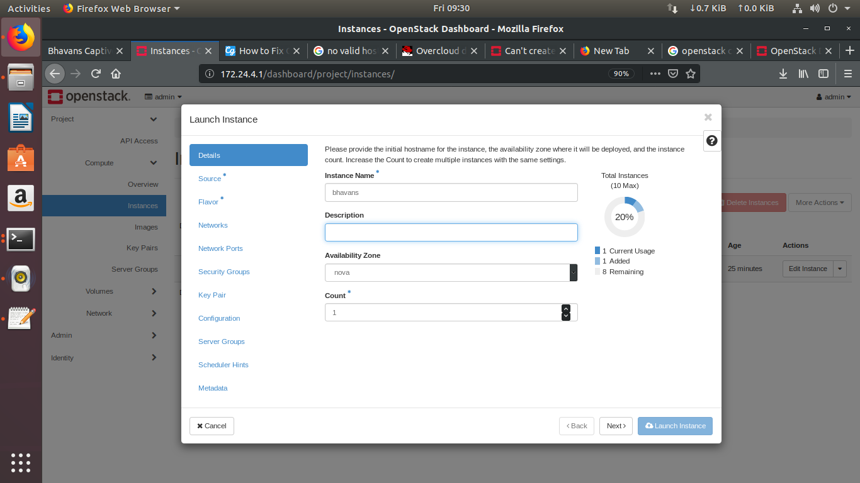

1. Under Source tab Select **Boot Source** as a Image and select the disk image.

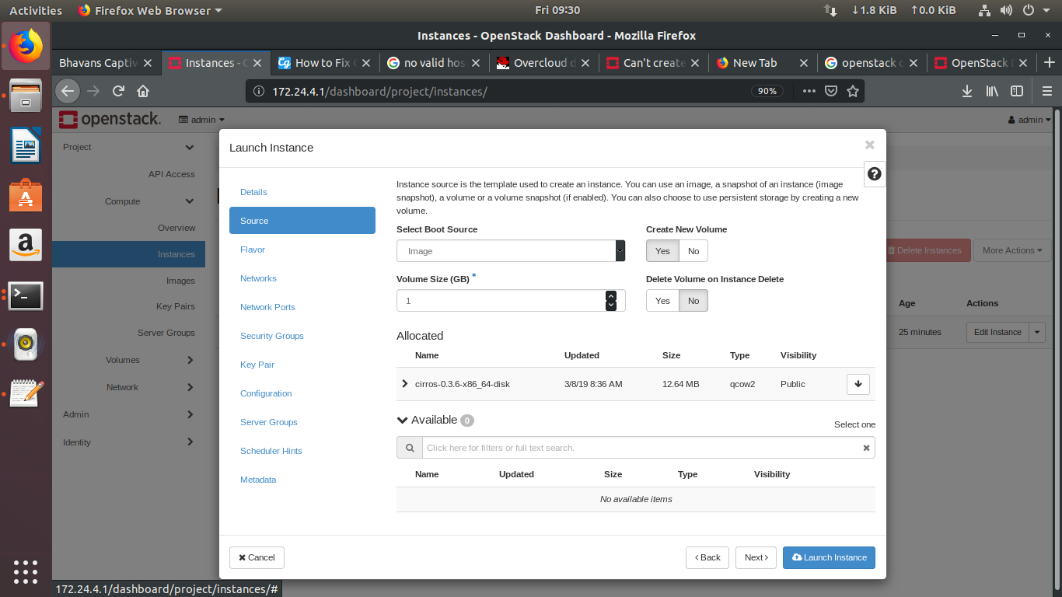

1. Under flavor tab select flavor for the instance.

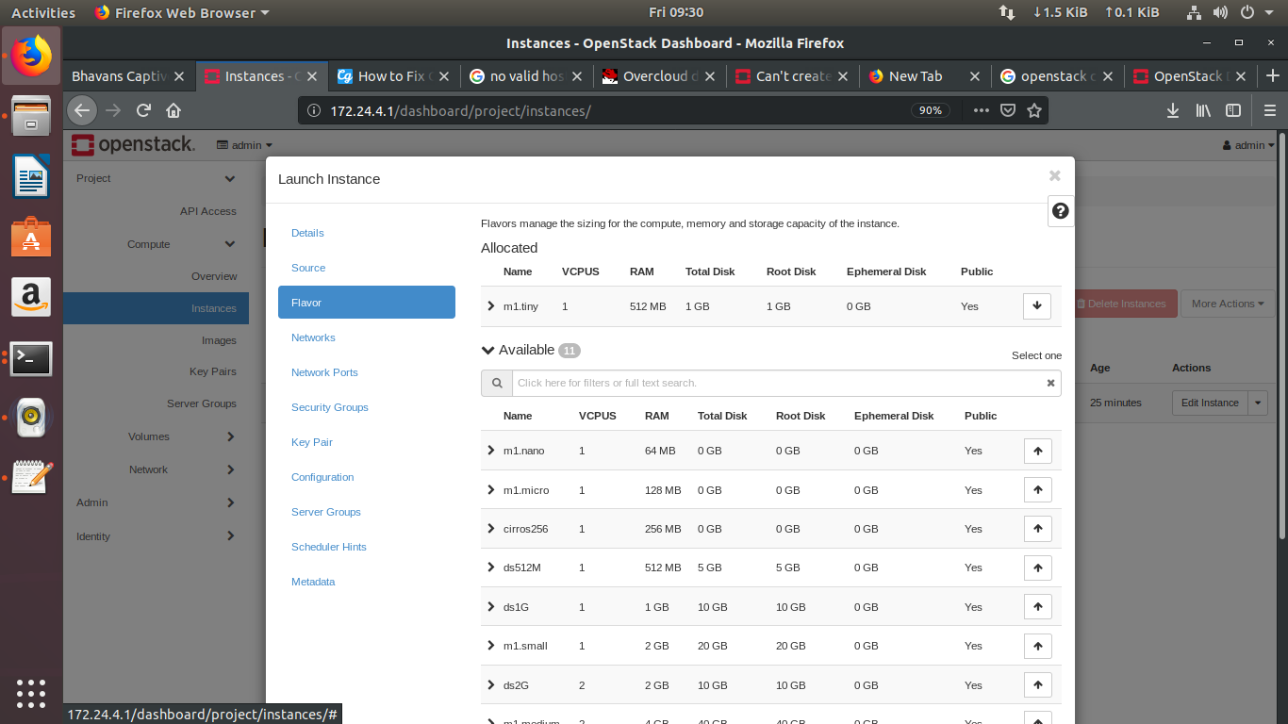

1. Under network tab select the network for the instance.

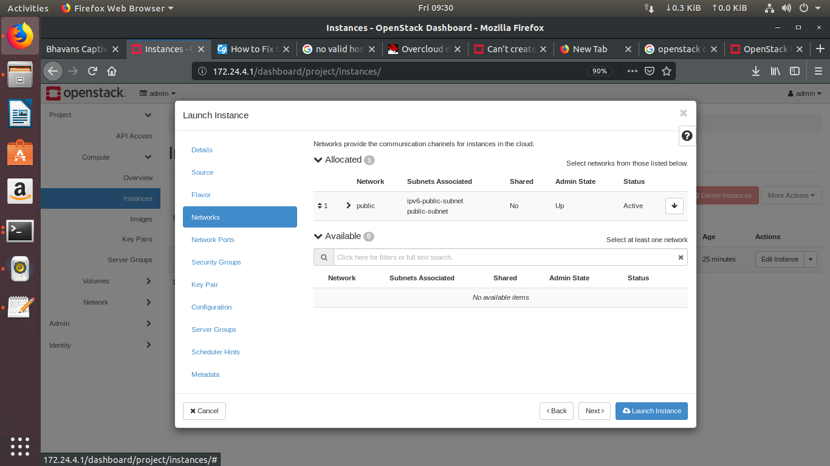

1. Click on Launch instance.

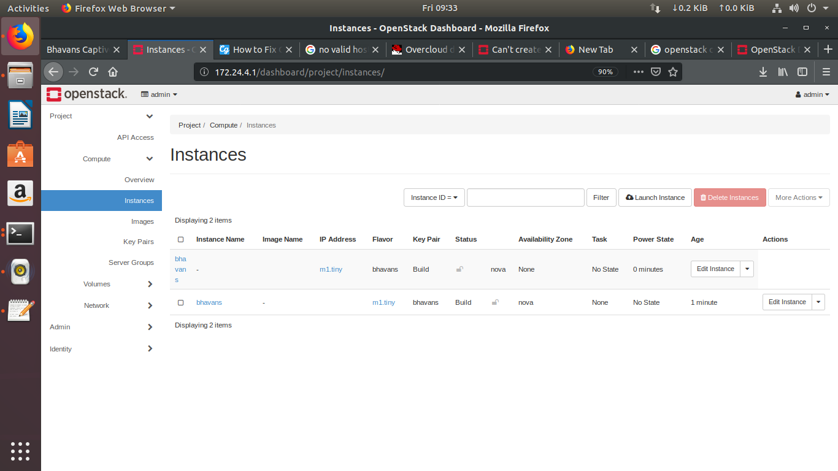

**Creating user:**

Go to Identity>>Users and click on create user.

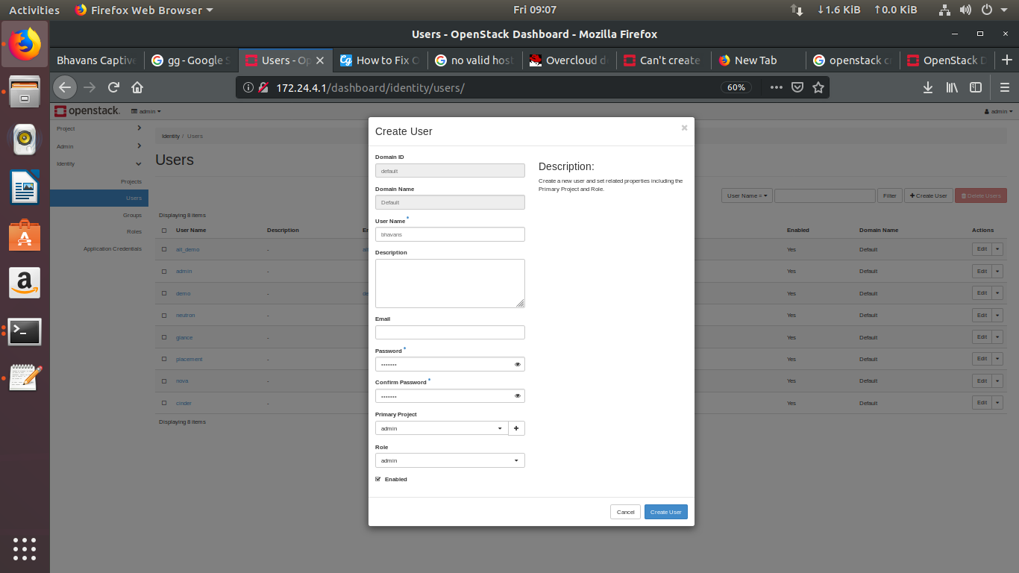

**Deleting user:**

Go to Identity>>Users and select the users you want to delete and click Delete Users.

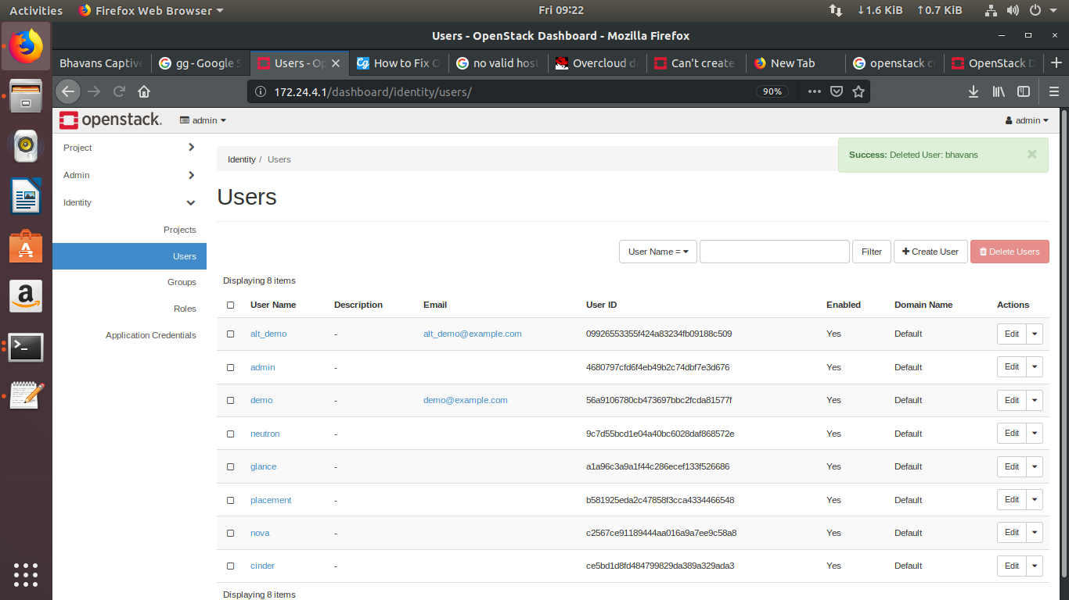

**Creating groups:**

Go to Identity>>Groups and click on Create Group button.

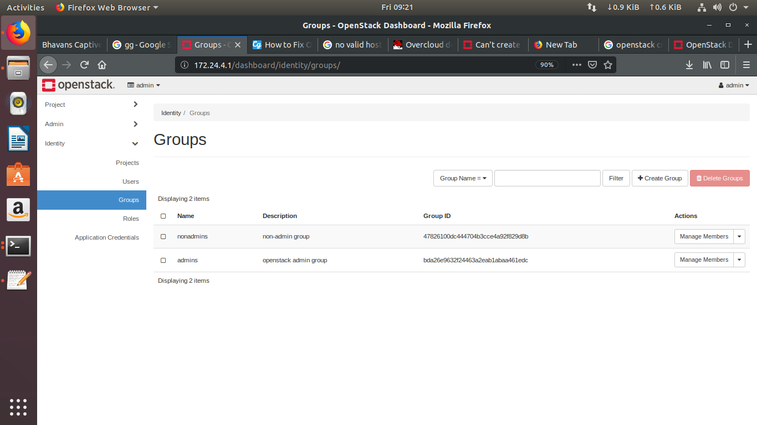

Give name and description to the group.

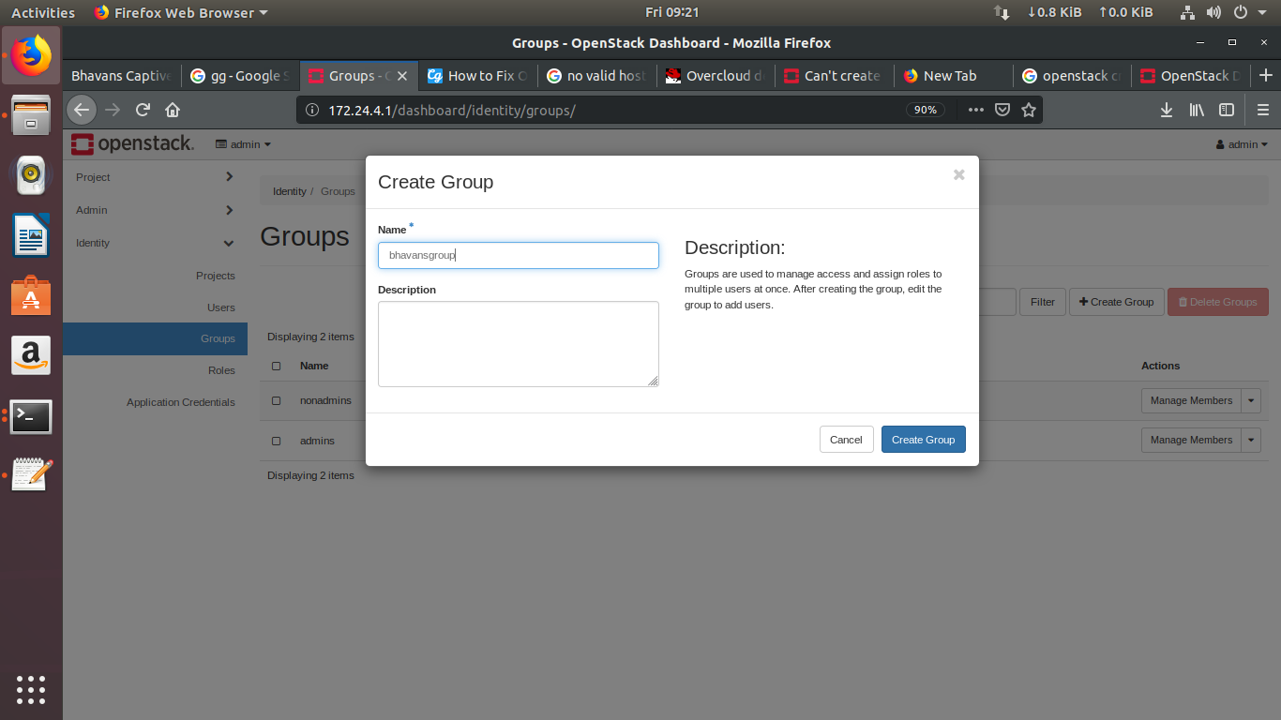

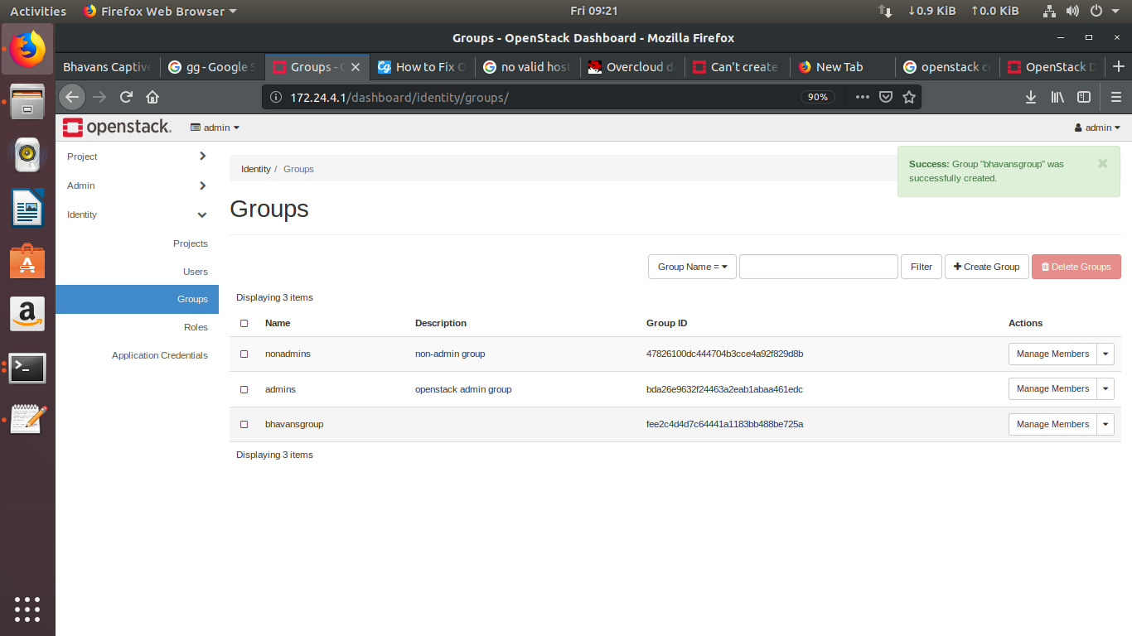

**Deleting Groups:**

Go to Identity>> Groups. Select the groups you want to delete and click on delete group button.

